PROJECT REPORT

1. INTRODUCTION

* 1. Overview

Carbon dioxide emission are emission stemming from the burning of fossil fuels and the manufacture of cement; they include carbon dioxide produced during consumption of solid, liquid, and gas fuels as well as gas flaring.

* 1. Highlights

Carbon dioxide (CO2) Fossil fuel use is the primary source of CO2. CO2 can also be emitted from direct human-induced impacts on forestry and other land use, such as through deforestation, land clearing for agriculture and degradation of soils. Land use, can also remove CO2 from the atmosphere through reforestation, improvement of soils, and other activities. Quantification of these benefits can be challenging and improved methodologies are needed to inform future policy and investment decisions.

1. PROBLEM DEFINITION & DESIGN THINKING

2.1 EMPATHY MAP

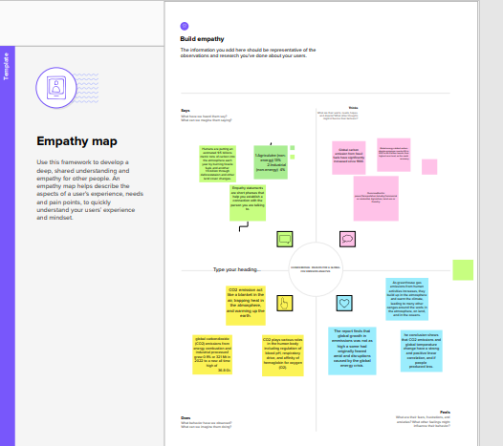

2.2 IDEATION & BRAINSTROMING MAP

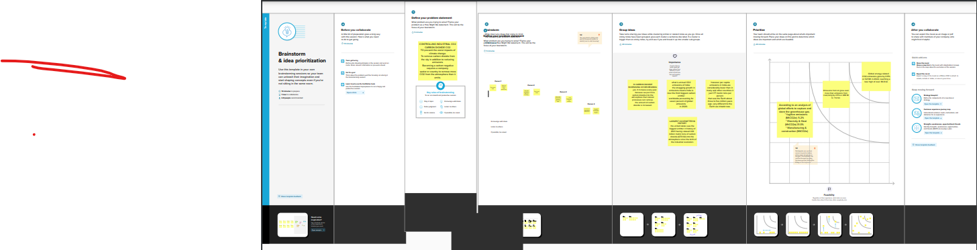

1. RESULT

TOP EMITTING COUNTRIES

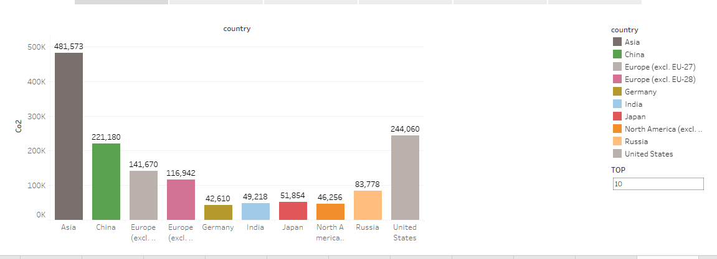

TOTAL CO2 EMISSION FROM 1975 TO 2020

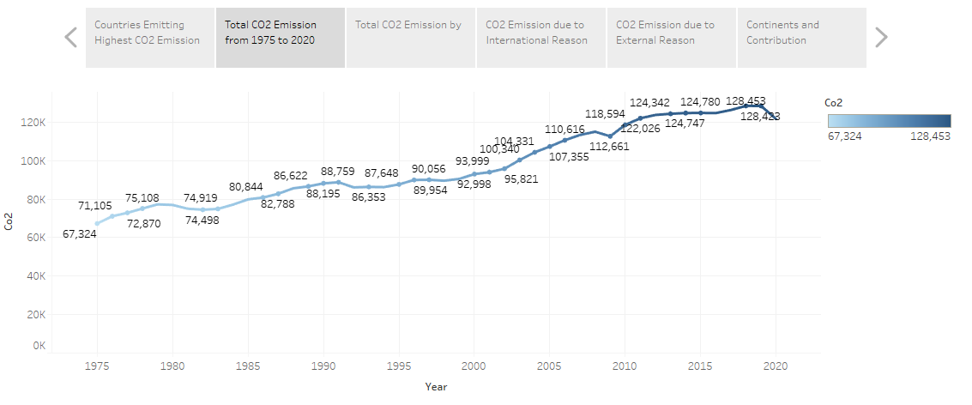

TOTAL EMISSION CONTINETNS

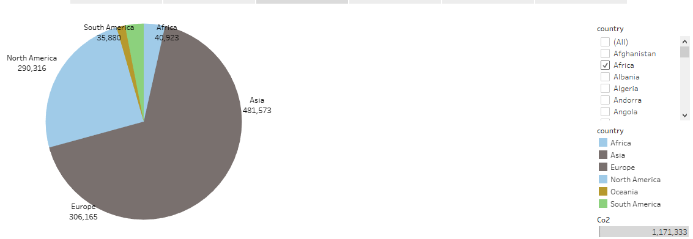

C02 EMISSION DASHBOARD (1)

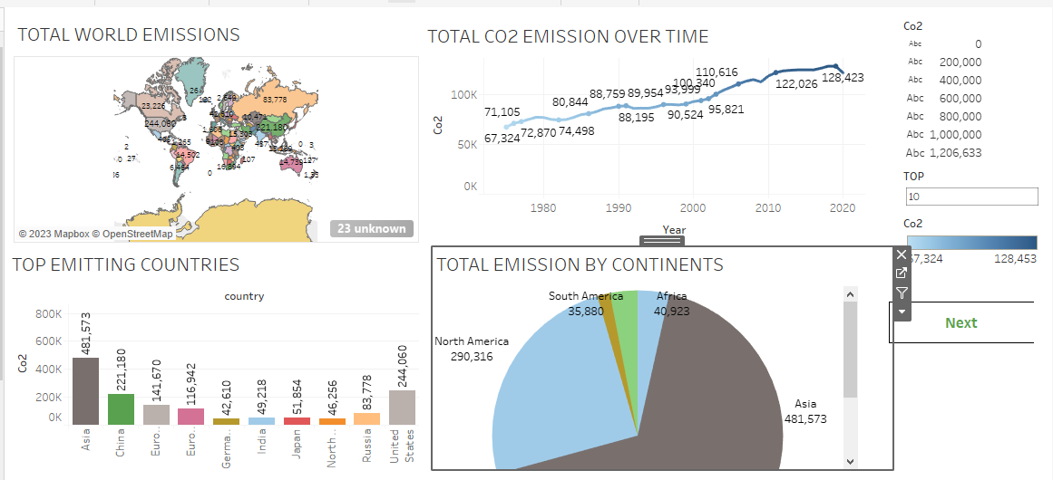

CO2 EMISSION DASHBOARD (2)

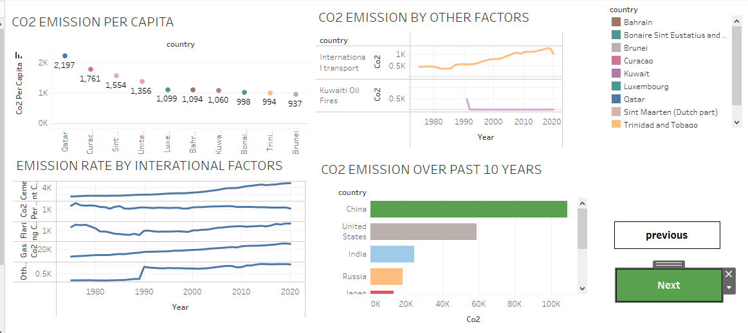

1. ADVANTAGAES

* Carbon dioxide is an important greehouse gas.
* It helps to trap heat in our atmosphere.
* Without it, our planet would be inhospitably cold.
* High thermal stability.

DISADVNTAGES

* It trapping heat in the atmosphere and warming up the earth.
* Global warming would affect environmental condition,food and water supplies.
* Low CO2 adsorption capacity.
* Loss of biodiversity.

1. APPLICATIONS

CO2 can be used to produce fuels and chemical intermediates through several conversion routes but require significant energy input. CO2 use can support goals when then application is scalable. Use low carbon energy and displaces a product with higher life-cycle .

1. CONCLUSION

Carbon capture and seqestration is an attractive option for reducing greenhouse gas emission and could even help remove carbon dioxide from the atmosphere.

1. FUTURE SCOPE.

CO2 emission from energy combustion grew by arount 1.3% or 423 Mt 2022, while CO2 emission from industrial process defined by 102 Mt.

1. APPENDIX
2. Source Code

Dashboard link:

<https://public.tableau.com/views/Book1_16823422113750/Dash3?:language=en-US&publish=yes&:display_count=n&:origin=viz_share_link>